Some of the ancient Roman
Virtues promoted by Nova Roma:

Dignitas (dignity) – Self-worth and personal pride.

Veritas (truth) – Truthfulness and honor in the conduct of everyday affairs.

Pietas (piety) – Honor, reverence and dutifulness to the Gods.

Honestas (respectability) – Maintaining a respectful image as a productive member of society.

Humanitas (humanity) – Refinement, learning, civilization, and culture.

Firmitas (tenacity) – Strength of mind, the ability to stick to one’s purpose.

Comitas (ease of manner) – Openness, courtesy, friendliness, and a pleasant sense of humor.

Industria (industriousness) – Achievement through good effort and responsible work.

Clementia (mercy) – The ability to be kind, mild, and generous in one’s attitudes.

Salubritas (wholesomeness) – Maintaining a healthy and positive lifestyle.

Frugalitas (frugalness) – Economy and simplicity of style, rather than being restrictive or miserly.

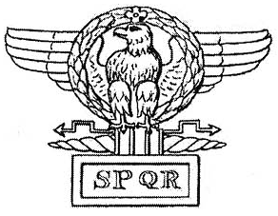
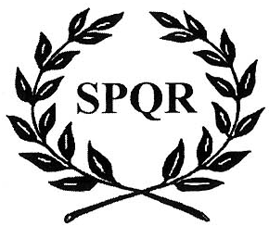

As a sovereign Micronation, Nova Roma is proud to be the most comprehensive international cultural resource for people interested in all aspects of ancient Rome and the Classical world, including:

- Classical history
- Ancient religion
- Ancient philosophy
- Cultural and military reenactment
- Classical politics
- Archaeology
- Classical literature
- Latin language
- Roman law and legal systems
- Ancient art and architecture
- Historical preservation

Inquiries welcome.

There’s a local chapter of Nova Roma in your area!

Nova Roma: Civitas Boreocaesarium
(North Jersey Community)

973-426-1035

NOVA
ROMA



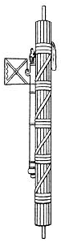 | A Micronation dedicated to the study and restoration of Classical Roman culture, religion, and society. | 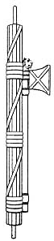

THE REBIRTH OF CLASSICAL ROMAN RELIGION AND CULTURE

Since the fall of the Western Roman Empire in the fifth century CE, many have aspired to reclaim the best essence of Roman civilization. For centuries, classical Rome has remained the standard to which all cultures have compared themselves. The Roman legacies in art, architecture, law, politics, commerce, and ancient religion are the basic foundation of our world today. They are the eternal common heritage shared by all existing Western nations.
Nova Roma has been created so that the greatest qualities of the ancient Roman world may be not only remembered, but restored and brought forth as a vital, living force. Existing as a “Micronation”, a small international sovereign state, Nova Roma is dedicated to the study and revival of Roman religion, culture, and society.
The goal of Nova Roma is to restore ancient Virtue, Piety, and Dignity by manifesting a working “Roman Republic” which embodies all the best qualities of classical civilization. As a micronation we seek, through positive example, to inspire and revitalize the peoples and countries of the world today. Our future hope is to establish a Roman Forum as a “world capitol” which will serve as a focus for classical Roman religion and culture worldwide.
Nova Roman Citizenship is open to all. We do not discriminate on the basis of race, nationality, religion, or gender. Becoming a Citizen allows one to participate in all aspects of our micronation, and is simply the most complete way to become involved in any aspect of the history and culture of the classical Roman world.
We invite you to explore Nova Roma and to take part in the most comprehensive effort to restore the Classical Ideal that exists today. Together we can rebuild the best of what has been lost over the centuries, and improve the quality of our common future!
The work of Rebuilding…

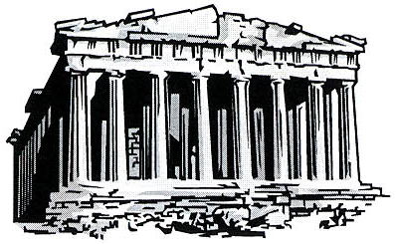

Nova Roma promotes a variety of activities related to our goal of restoring the best aspects of classical Roman civilization. These include:

- Maintaining a worldwide “micronation” based on the Republican Roman model, with its own government and limited sovereign status, while remaining subject to the laws of the countries in which we live.
- Restoring the Pax Deorum through the revived public practice of the Religio Romana (ancient Roman pagan religion).
- Funding archaeological works of excavation and preservation of ancient Roman sites.
- Encouraging the practice of the ancient Roman virtues in popular culture and life.
- Sponsoring and promoting ancient Roman religious and historical events and festivals.
- Working with Roman cultural and military reenactment groups, to ensure that our past remains alive, not consigned to history books.
- Cooperating with reconstructionist groups of other ancient cultures and faiths.
- Researching and publishing ancient Roman historical and religious material.
Why become a Citizen
of Nova Roma?

Citizenship in Nova Roma is free. By becoming a Citizen, you will have many opportunities for involvement in ongoing classical Roman events and subjects, such as:

- For adults, participation in our elections and plebiscites, and the opportunity to run for elected office as a magistrate.
- Access to the ancient rites and rituals of the Religio Romana, as well as practical assistance for those who wish to practice it.
- Interaction with other Nova Roma Citizens at Roman gatherings and events, and also online through the Internet.
- Access to official Nova Roma publications and materials, and also discounts on items from selected merchants.
- Assistance with research in a wide variety of Roman-related studies.
- The chance to subscribe to and submit articles for our official newsletter, The Eagle.
- The opportunity to participate in public service projects.
- And much, much more!

Visit the Nova Roma web site at:
http://www.novaroma.org

Please send me information on Nova Roma, as I do not have Internet access and cannot visit your web site. I understand that this places me under no obligation, nor will I be put on a mailing list. Please mail information to:

Name:

Address:

City/State/ZIP:

Send to:

Nova Roma, P.O. Box 1897, Wells, ME 04090

